**EGR 425 Spring 2018  
Lab #4**  
**Due Mon Feb. 19, 2018 11:59PM**

* You are to reuse the same code and setup from Lab3 (traffic light system with 1 walk signal). In this lab, you will add an LCD to your setup. Use SPI to transfer bytes to your LCD. Make AVR the Master and LCD the Slave. Transfer bytes to display to the screen. Following are detailed instructions.

1. Wire the LCD as shown below. You will need to move your LED Pins to use PortD. And your push button to use PortC (or wherever you have space).

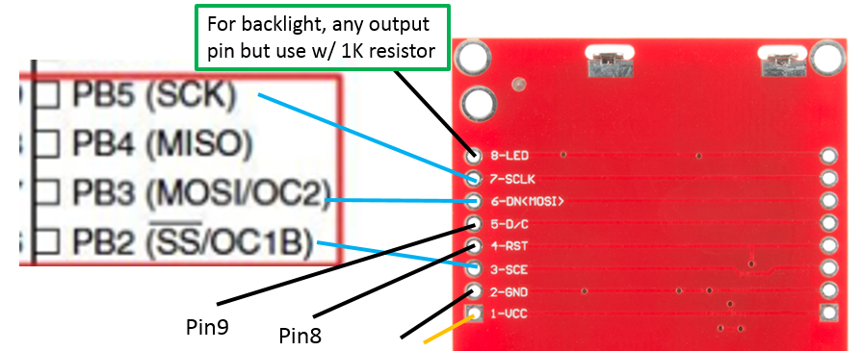

1. After wiring the LCD, make sure your traffic light + buzzer + push button still works before moving on.
2. Implement the following initialization code.
   1. Implement this function to initialize SPI: **void spi_init()**
   2. Template code for lcd init is given in: **void lcd_init()**
      1. You will need to configure the appropriate DDRB and PORTB values for LCD, following the lecture
   3. Implement function to clear the LCD screen: **void lcd_clear()**
      1. Once this is called, the LCD screen will be “blanked out” with spaces.
3. Implement the following functions to send data and commands
   1. **void write_cmd(uint8_t cmd)** – send commands to LCD using SPI
   2. **void write_data(uint8_t data)** – send data to LCD using SPI
4. Implement the following functions to be able to write characters to LCD
   1. **void write_char(uint8_t data)** – write a single character to LCD. Use the provided lcd_chars.h file to figure out the 5 bytes to output to print a single character.
   2. **void write_string(char string[])** – use a loop to write multiple characters
5. Using a combination of the above functions and remembering that the LCD screen shows a total of 504 bytes, add the following features to your traffic light system.
   1. The LCD will act as a WALK signal. When there are cars passing by, display a STOP sign. And also a short text for walkers to read as they kill time.
   2. When the WALK signal is given (by the walker pressing the button), display a WALK sign.
   3. The above are the minimum requirements. You may do anything beyond this as you wish.
   4. You can use tools that convert bitmap images to bytes such as this one:
      1. <http://en.radzio.dxp.pl/bitmap_converter/>

**Lab4 Deliverables – Turn this in Individually**

1. Upload lab4.c and lcd.c (One per team)